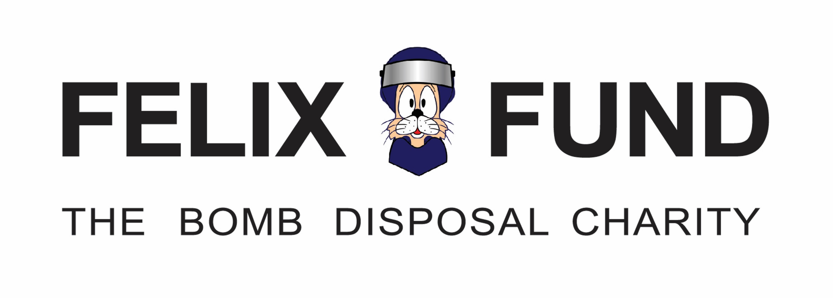
Date Received:
Reference No:

Application for a Felix Fund Grant

Felix Fund helps military personnel serving or retired who have conducted or assisted with EOD and Search duties; we also support their dependent family members.

Applications will be considered when:
- there would be a clear welfare/rehabilitation benefit to the recipient(s) and
- the required funds are not available from other sources. (Welfare benefits or statutory payments etc.)

We welcome applications from EOD &b Search units and individuals of any cap-badge, including: ATOs/ATs, #2s, ECM Operators, Drivers, Infantry Escorts, Searchers, Weapons Intelligence Specialists, Dog Handlers, plus any other military personnel who have conducted or assisted bomb disposal duties. We welcome applications from personnel on behalf of those listed above.

- Please complete sections 1-8 in as much detail as possible - incomplete applications will be rejected
- Please attach quotes, advertised prices and supporting documents
- Return completed forms to enquiries@felixfund.org.uk

All requests for assistance are treated confidentially and in line with Felix Fund’s Safeguarding Policy which can be found on our website www.felixfund.org.uk.

Part 1: Applicant Details
Name:
On behalf of (if applicable):
Unit:
Address:
Postcode:
Telephone: | Email:

Part 2: What do you need?

Part 3: - Why do you need it?
How many people will benefit from this request?

Part 4: Project, Budget Breakdown including VAT:
Total Cost of the project including VAT
Amount requested from Felix Fund including VAT

Part 5: Which organisations have you applied to? And how much have you requested?
Charity Name | Have they agreed to assist you? | Requested amount £
PRI | Yes No
ECOPF | Yes No
Other Charity/s Please name below
Yes No
Yes No
Yes No
Yes No
Felix Fund | Yes No
Will there be a personal contribution? | Yes No
 | Total requested: £
 | Total Agreed: £

Part 6: Time Frame
Felix Fund’s trustees meet four times a year. However, trustees will consider requests at other times in between meetings. If you feel your case is genuinely urgent, please explain why.
When is the decision needed by?
Part 7: - Payment Details
If your application is successful, how would you prefer to receive payment?
by cheque payable to
by bank transfer | Bank Name:
 | Account Name:
 | Account Number:
 | Sort Code:
Felix Fund will not pay third party suppliers for goods. Payment must be made to the individual.

○
○
○
Part 8: Your declaration
I have enclosed copies of all quotes, advertised prices and other supporting documents.
All the information on this form is correct to the best of my knowledge.
I give permission to Felix Fund to use my grant application should it be awarded, in future fundraising
initiatives. (names will be changed if requested)

To be completed by Felix Fund only:
□
□
□
○
○

Part 9: Trustee Authorisation
Request Approved Not Approved Approved by email
Signature of Trustee: |  | Date
Signature of Trustee : |  | Date
Signature of Trustee: |  | Date

Part 10: Felix Fund Treasurer
Payment Method: | Date
Voucher Number: | Date
Signature of Treasurer: | Date

Part 11: Data Protection
I am aware that by law Felix Fund needs to retain my information for a period of 6 years.
I can at any time request details of my personal information stored. (please tick the box)
Felix Fund complies with all Data Protection and Privacy laws as laid down by the UK Government.

Completed forms should either be emailed to enquiries@felixfund.org.uk or posted to: Felix Fund, Vauxhall Barracks, Foxhall Road, Didcot OX11 7ES.

Please note: If your grant is for an adventure training activity there musts firstly be a welfare benefit and Felix Fund will now pledge an amount towards the activity with the funds be paid over once the trip has been completed.

